For your diary, 2023/4 Programme of Friends Lectures and Events

Programme for 2024 spring/summer season

9th January 2024, 7.30 pm, The Barbican Studio at The Higgins
Simon Carter on The Artists of St Paul's Cathedral.

30th January 2024, 7.30pm, venue TBA
Paul Middleton on John Seymour Lindsay and the First World War

6th February 2024, 7.30 pm, by Zoom
Christopher Joll on Nelson, death, fate and a coffin

Thursday 15th February 2024, evening at The Higgins
Private view of Edward Bawden and Me
Join us and the exhibition artists for an opening celebration.
Invitations will be sent out nearer the time.

20th February 2024, 7.30 pm, venue to be confirmed.
Lucy Lewis the Army’s first female bomb disposal expert, now running the Marshals of Cambridge University on Lighting the Fire

5th March 2024, 12 Noon, venue The Bunyan Meeting, best car park, Lurke Street MCP MK40 3HZ
Victoria Partridge on Edward Bawden and Me
Includes a private guided visit to the exhibition

Wednesday 13th March 2024, 7.30 pm, venue to be confirmed
Jonathan Foyle on Climbing Great Buildings
Generously sponsored by | 

16th April 2024, 7.30 pm, venue to be confirmed
Christopher Joll on A Bonfire of History - lost treasures of Madame Tussaud's

23rd April 2024, 12.00 noon, venue to be confirmed
Victoria Partridge on William Burges
Generously sponsored by AGNEWS GALLERY LONDON

21st May, 7.30 pm, venue to be confirmed
Hugh Belsey on Gainsborough’s Career – from Ipswich to Bath – on his tercentenary

MAY VISIT – Hopefully to Cirencester Park by coach – details to follow –
also a picnic at Turvey House – date to follow

25th June 2024, 7.30 pm, venue to be confirmed
Generously sponsored by Lady Whitbread
Jonathan Foyle on Old Warden Church and Anne of Cleves

June 2024 date to be arranged at lunchtime, venue The Higgins
David Boyd Haycock on his new book on Lucy Kemp Welch.

SUMMER BREAK AND MEMBERSHIP DONATIONS RENEWAL FOR 24/25

3rd September 2024, time and venue TBA
Dr Giorgia Bottinelli, Director of the Norwich Castle Museum
on John Crome, a Norfolk artist

22nd October 2024, time and venue TBA
Boyd and Evans, on Artists in residence at Milton Keynes

29th October 2024, time and venue TBA
Michael Croker live Painting a Self-Portrait

5th November 2024, time and venue TBA
Helen Dawkins on Black and White Revival - restoring old photographs.

Additionally, and to be announced there will be private visits and special events at the gallery.

Friends’ website www.friendsofthehiggins.org

Donations please via justgiving

https://www.justgiving.com/onecheckout/donation/direct/charity/3086310

Past talks already enjoyed by Friends this season

5th September 7.30 pm, venue, St Andrew’s Church Hall, Kimbolton Rd, Bedford MK40 2PF
Generously sponsored by Sarah Flynn sarahflynn.fineart@gmail.com
Professor David Ekserdjian on The Altarpiece in Renaissance Italy.
Voted 5* by Friends’ Critic

26th September 7.30 pm, venue, St Andrew’s Church Hall, Kimbolton Rd, Bedford MK40 2PF Note title change
Generously sponsored by 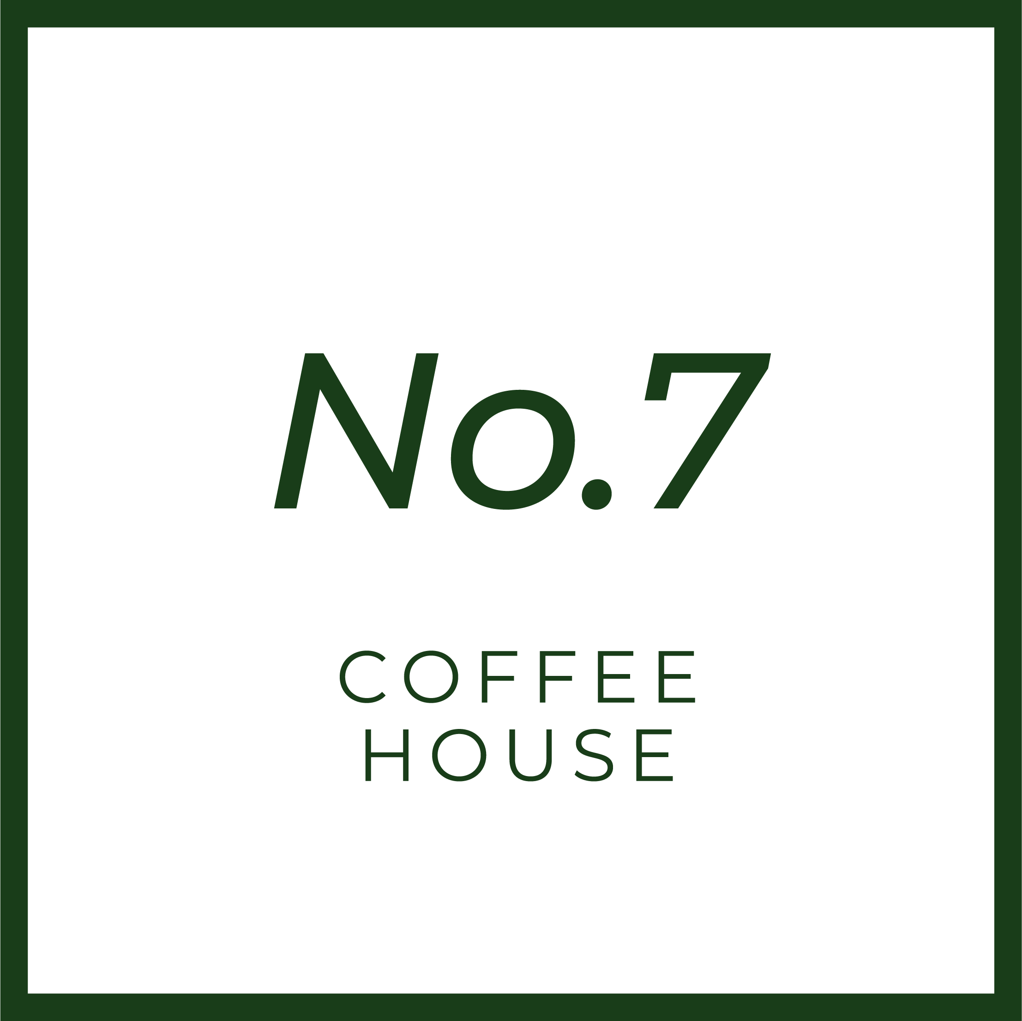
Dr Jane Ridley – George V: Never a Dull Moment.
Voted 4.5* by Friends’ Critic

24th October, 7.30 pm, venue, St Andrew’s Church Hall, Kimbolton Rd, Bedford MK40 2PF
Generously sponsored by
Patrick Baty on the The Artists of the Artists Rifles
Voted 5* by Friends’ Critic

7th November, 7.30 pm, venue, St Andrew’s Church Hall, Kimbolton Rd, Bedford MK40 2PF
Professor David Ekserdjian on The work and films of Powell and Pressburger.
Voted 4.5* by Friends’ Critic

28th November, 7.30 pm, venue, St Andrew’s Church Hall, Kimbolton Rd, Bedford MK40 2PF
Generously sponsored by | 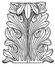 | DAVID FLETCHER VALUER
Dr Evelyn Silber on BARBARIAN, REBEL, PIONEER: Jacob Epstein ‘taking the brickbats for modern art.’
Voted 4.5* by Friends’ Critic

